COCKTAILS
ITALIAN OLD FASHIONED  House-infused orange and vanilla bourbon, maraschino  liqueur, orange bitters, orange peel, sour cherry | 14 |  | CRANBERRY MAPLE BOURBON  Home-made cranberry maple marmalade, house-infused  bourbon, cranberry, lemon, orange bitters | 14
LIMONCELLO MARTINI  Vodka, limoncello, lemon | 14 |  | APPLE CIDER MOJITO  Apple cider, rum, lime, mint, soda water | 13
CIAO COSMOPOLITAN  Vodka, orange liqueur, lime, cranberry, garnished  with an amareno cherry and dehydrated orange | 14 |  | DRUNKEN PUMPKIN CHEESECAKE  Vanilla vodka, irish cream, pumpkin syrup, horchata,  coconut foam | 14
ESPRESSO MARTINI  Chilled lavazza espresso, vodka, coffee liqueur,  irish cream. Make it a Tequila Tyler for a delicious twist | 14 |  | P.S.L. MARTINI  Pumpkin spice puree, vanilla vodka, coffee liqueur,  chilled espresso, cinnamon sugar rim | 14
TOASTED SMORES MARTINI  Coffee liqueur, Drambuie, horchata, toasted  marshmallow syrup, marshmallow & graham  cracker rim | 15 |  | BANANA BREAD MARTINI  Spiced rum, horchata, banana bread liqueur,  hazelnut liqueur, caramel drizzle, cinnamon sugar rim,  chocolate covered banana slice | 14
SPICY POMEGRANATE GINGER MARGARITA  House-infused jalapeno tequila, pomegranate, ginger  syrup, lime, orange liqueur | 13 |  | CRAN-APPLE MARGARITA  Tequila blanco, apple cider, cranberry marmalade,  orange liqueur, lime | 13
JOLLY RANCHER APPLE-TINI  Apple vodka, sour apple schnapps, orange liqueur,  lemon | 14 |  | FIGA  Earl Grey infused vodka, muddled fig, blood orange,  caramelized fig syrup | 13
PRICKLY PEAR  Gin, dragon fruit, pear, lemon, passionfruit liqueur,  kiwi puree | 14 |  | MAPLE FRENCH TOAST  Caramel vodka, horchata, caramel irish cream,  maple, cinnamon | 14
STONE WALL  Spiced rum, apple cider, ginger, ginger beer,  garnished with crystalized ginger and apple | 13 |  | SEASONAL SANGRIA (Red or White)  Glass – 13 / Pitcher- 40

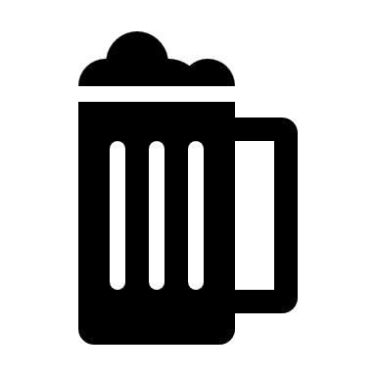
BEER ON TAP
Stella Artois  Belgian Pilsner beer | 11
Wandering Haze- Cisco, Nantucket MA  Slightly hazy wheat ale | 11.5
Sluice Juice – Bent Water, Lynn MA | 11
New England IPA
16 oz Cans
Tropical Trainwreck – C.M.B., Beverly MA  Inspired by Seagrass Dispensary, Salem | 7
Thunderfunk – Bent Water, Lynn MA  West Coast style IPA | 9
Premium Lager – Bent Water, Lynn MA  Pre-prohibition-style lager  Bottles | 9
Samuel Adams Boston Lager | 6
Blue Moon | 6
Corona | 5
Heineken | 5
Michelob Ultra | 5
Coors | 5
Bud Light | 5
Budweiser | 5
Modelo | 6
Peroni | 6
Bud Light Seltzer | 5
Bud Light Seltzer Lemonade | 5
Angry Orchard | 6
Kombrewcha Hard Kombucha | 5
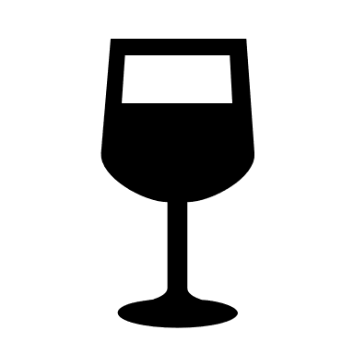
RED WINE

Pinot Noir Josh Cellar California | 13/52
Chianti Donna Laura DOCG Alteo, Vinous-Tuscany, Italy | 12/48
Nero D’Avola Villa Pozzi, Italy | 10/40
Cabernet Sauvignon Francis Ford Coppola, California | 14/56
Valpolicella Superior Agricola Cottini,  Veneto, Italy | 15/60
Campore Etna Rosso, Sicily, Italy | 15/60
Sangiovese Tenuta Sassoregale, Maremma Toscana | 12/48
House Red Fortissimo | glass 6  carafe 18
WHITE WINE

Tenuta La Falcona Bianco di  Custoza Veneto, Italy | 11/44
Pinot Grigio Santa Marina,  Friuli-Venezia, Giulia, Italy | 9/36
Sauvignon Blanc CK Mondavi, California | 9/36
Chardonnay Josh Cellars, California | 11/44
ROSE & SPARKLING

Rose Fleur de Prairie, Provence, France | 12/52
Prosecco Zonin, Veneto, Italy | 11/52

